Troubleshooting Network Drivers in Linux

The following Screen shots are taken to show what kind of commands are useful in troubleshooting network drivers’ issues on Linux Generally.

Please view he pictures and keep this document as a reference for future use.

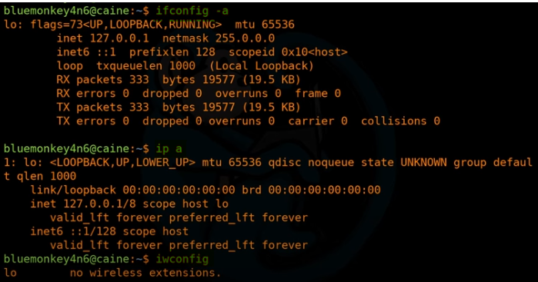

The commands above is to view the current status of the network drivers and interfaces.

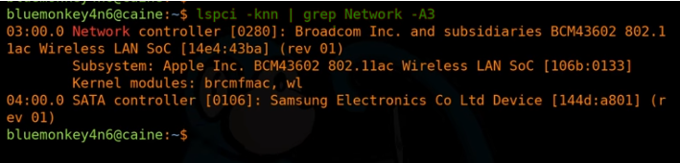

Explanation of the above command:

lspci: *This is a command to see all the hardware components*

-knn: k for kernel drivers handling each device and nn for pci vendor and vendor codes as both numbers and names.

| grep: this is to filter based on a given condition after, in this case it will be Network -A3

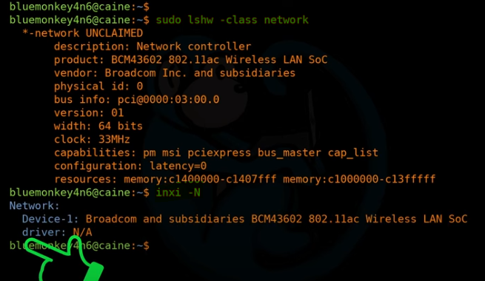

This is another command line where you can see network and its status. Also inxi -N is another command line that displays the information related to the network driver

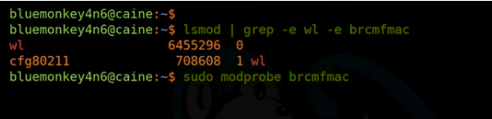

The following command is to check the mode of the devices to see if the kernel can read them or not, and the second command is issued to make the kernel read the devices and models.

After issuing the command, it will activate automatically.

Keep in mind, commands might vary slightly between different versions and distributions.

So it is good and wise to keep in mind the differences to get the results.